

**Receiving and Receiving Inspection Group**

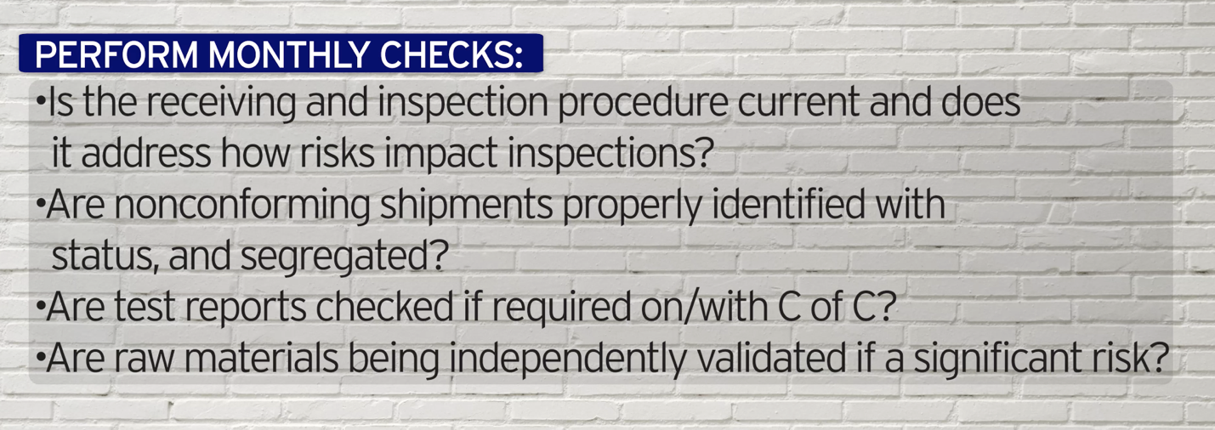

***World-Class in Performance. World-Class in Compliance.***