**Purchasing Group Lead**

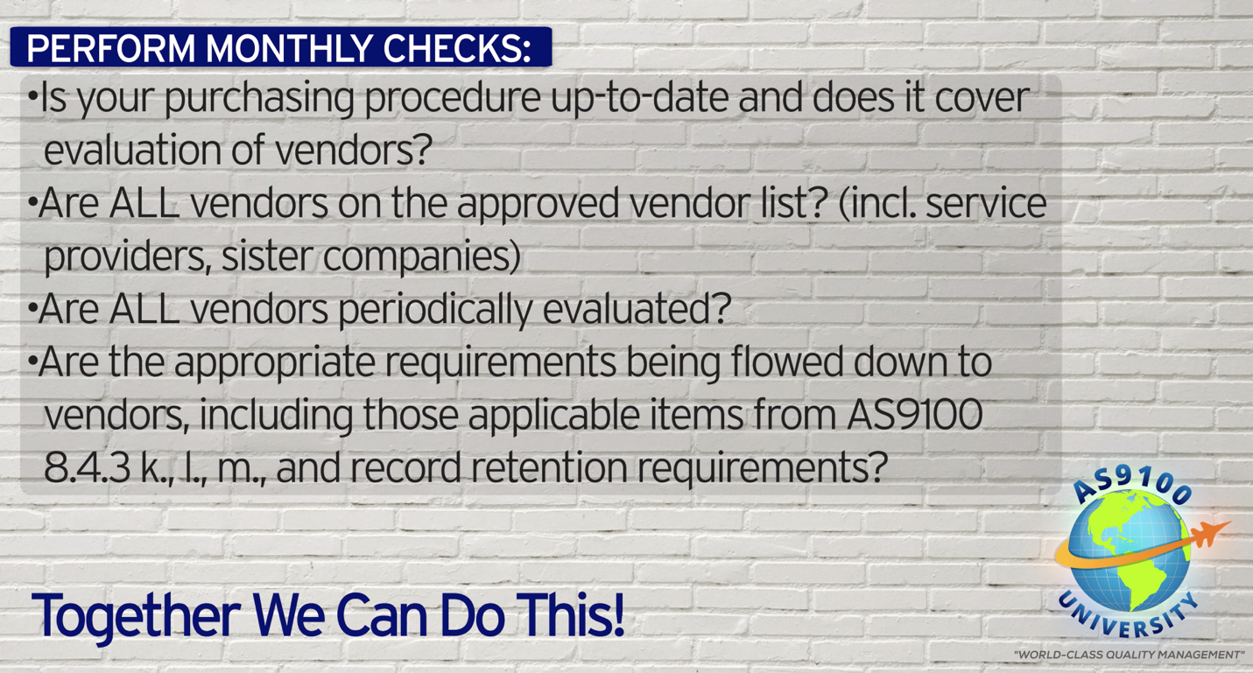

***World-Class in Performance. World-Class in Compliance.***