

**Production Work Group (video 2 of 2)**

**Job Documentation Check**

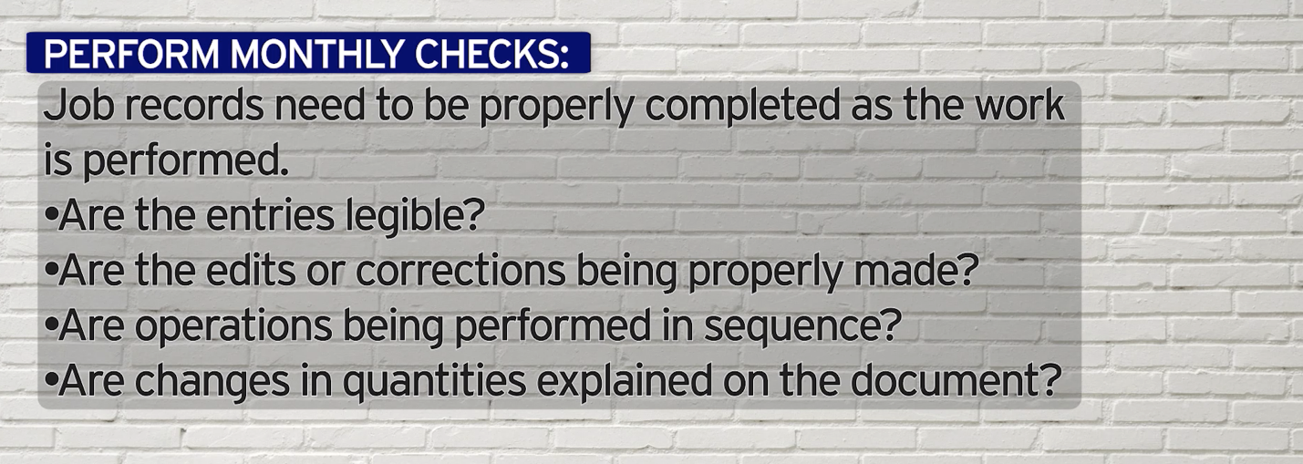

***World-Class Performance. World-Class Compliance.***