

**Production Work Group Check (video 1 of 2)**

**Equipment and Parts Check**

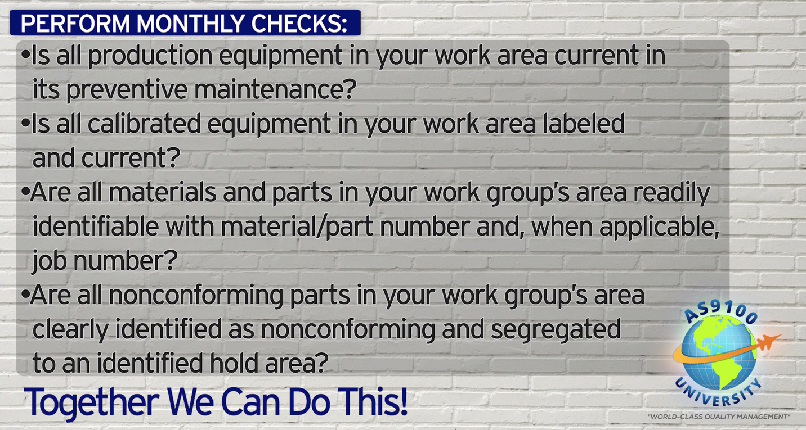

***World-Class in Performance. World-Class in Compliance.***