

**Management Representatives**

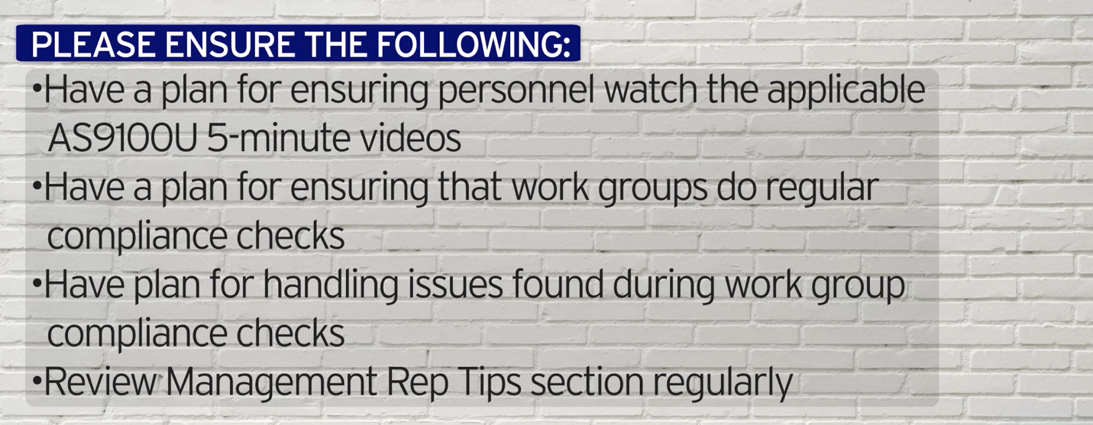

**World-Class in Performance. World-Class in Compliance.**