

**Internal Auditors**

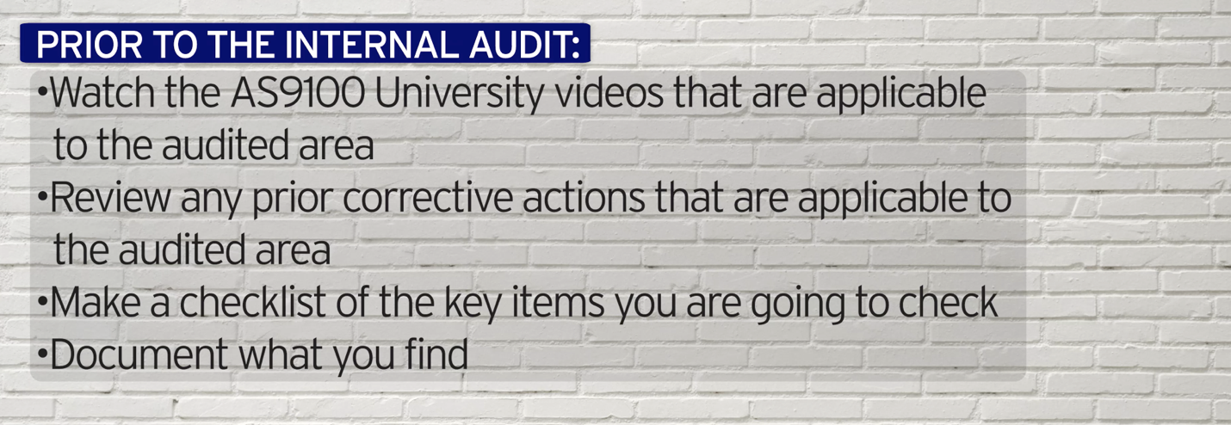

***World-Class in Performance. World-Class in Compliance.***