

**Control of Records and Governing Documents**

**Perform Monthly Checks:**

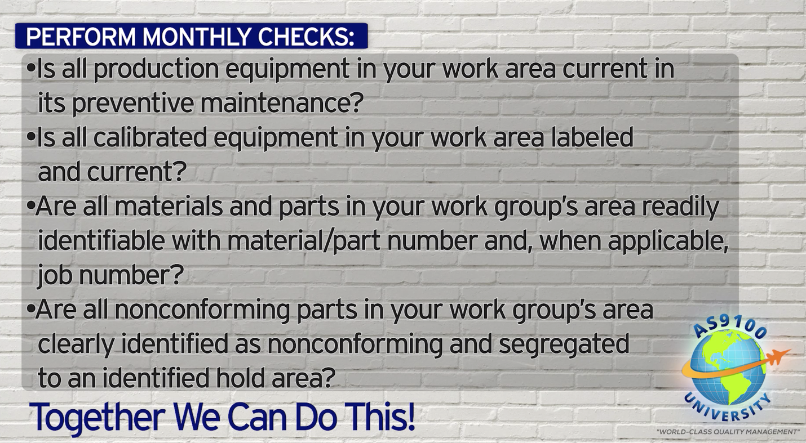

**World-Class in Performance. World-Class in Compliance.**

* **Legibility of initials and signatures are not required if your company has an initial and signature log that identifies which initials and signatures belong to which person.**