

**Corrective Action LEADs (video 2 of 2)**

**Root Cause and Corrective Action**

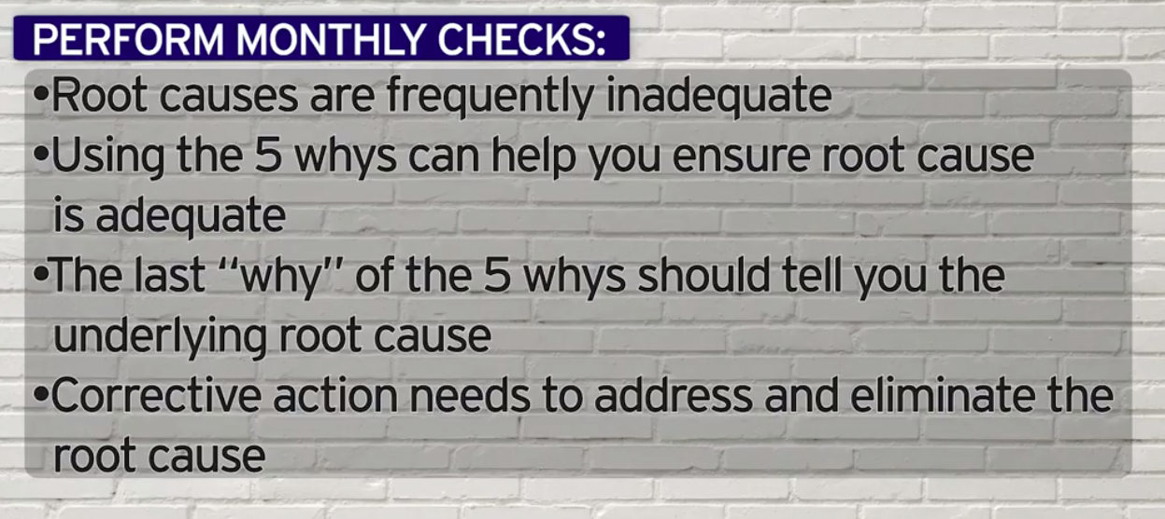

***World-Class in Performance. World-Class in Compliance.***