

**Calibration and Recall LEAD**

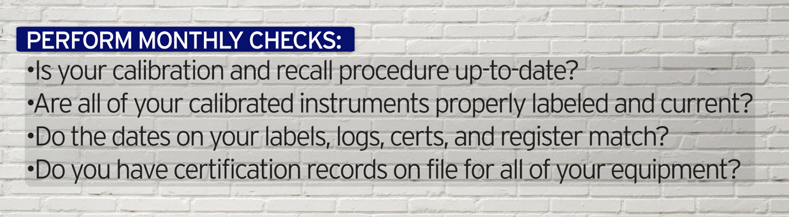

**Note: Are measuring instruments not in the calibration and recall system clearly marked? (E.g., with labels stating “Not in Service”, “Cal Before Use”, etc.)**

***World-Class in Performance. World-Class in Compliance.***